PACKAGING SPECIFICATIONS FOR IDAHOAN®
CREAMY CLASSIC MASHED POTATOES
Item #: 2970000311
Issued: December 5, 2025
Supersedes: December 15, 2021

I. PRODUCT DESCRIPTION
Idahoan® Creamy Classic Mashed Potatoes are processed from sound, well peeled, and trimmed 100% Idaho® Potatoes. The product complies with the provisions of the Federal Food, Drug and Cosmetic Act and Amendments.

II. INGREDIENTS
Idaho® potatoes, salt, sunflower oil, nonfat dry milk, mono- and diglycerides, calcium stearoyl lactylate, natural flavor, spice, turmeric (color), riboflavin (color). Freshness preserved by sodium acid pyrophosphate, sodium bisulfite, citric acid and mixed tocopherols..

III. NUTRITION
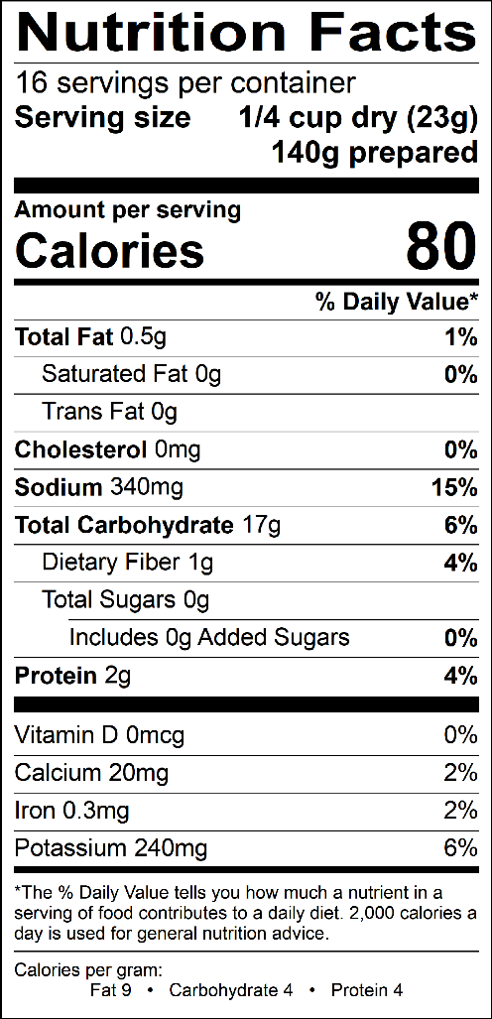

IV. FINISHED PRODUCT REQUIREMENTS

- Potato see Specification #2200002

- Packaged Product
Physical & Chemical Attributes | LSL | Target | USL
Moisture |  |  | 9.0%
Salt | 3.3% | 3.5% | 3.8%
Metal Ferrous (mm)  Non-Ferrous (mm)  Stainless (mm) |  |  | 2  2  2.5
Foreign Material | None Detected

Microbiological Attributes | LSL | Target | USL
Standard Plate Count/g |  |  | 50,000
Coliform/g |  |  | 50
Yeast and Mold/g |  |  | 100

C. Preparation
1. Control is prepared with 369 g potatoes (#2200002).
2. Add ½ gallon of boiling water to a 4” deep ½ size steam table pan.
3. Add potatoes all at once and stir to wet all potatoes. Let stand one minute.
4. Mix well and evaluate.

D. Prepared Product
1. Color – typical, cooked, rich, potato color ranging from cream to creamy yellow. No objectionable darkening 2 hours after preparation.
2. Texture – typical, creamy, fluffy, mashed potato texture-free from gumminess and pastiness.
3. Flavor and Aroma – normal, cooked, buttery, potato flavor and aroma. Free from objectionable foreign flavors and odors.

V. PACKAGING

- Components
Components | LSL | Declared Weight | USL
Potatoes #2200002 | 361 | 369 | 377
Finished Product #000311 | 361 | 369 | 377

B. Packaging
Product is packaged in a moisture and gas resistant poly pouch. Net weight per pouch is 13 ounces (794 grams), 24 pouches per case.

C. Pouch and Case Condition
1. Date codes legible and correctly positioned on pouch and case
2. Pouch film must be centered correctly horizontally and vertically
3. All pouches completely sealed along top and bottom and down back
4. No crumpled or bunched heat seals
5. No crushed or twisted cases

VI. SHELF LIFE & STORAGE INFORMATION
The shelf life is approximately 12 months from date of packaging code (imprinted on the package), when stored away from direct heat, in a cool, dry location, away from strong contaminating odors. Storage conditions should not exceed 80°F and 60% R.H.

VII. ALLERGENS
US – Milk INTERNATIONAL – Milk, Sulfites

VIII. CERTIFICATION
Dairy Kosher

IX. SAMPLE DATE CODING
1209 LWA 15:68

